# ARTICULO ORIGINAL Rev. Methodo 2024;9(2):08-14

# <https://doi.org/10.22529/me.2024.9(2)03>

|  |  |
| --- | --- |
| Recibido 27 Dic. 2023 | Aceptado 24 Nov. 2023 |Publicado 05 Abr 2024 |  |

**Achieving target blood pressure and LDL Cholesterol does not prevent the progression of atherosclerotic plaque burden in a high-risk population**

**Alcanzar la presión arterial y el colesterol LDL objetivo no previene la progresión de la carga de placa aterosclerótica en una población de alto riesgo**

Hernán Alejandro Pérez1[](https://orcid.org/0000-0002-6358-7940) , Enrique A. Majul2, Ana Laura Oliszynski3, Delia Agustin3, Delfina Bocchetto3, Candela Albrecht3, Iara Milena Báez3, Ignacio Foa Torres3, Luz María González Rinaldi3, Sofía Lambrechts3, Sonia Muñoz4, Mariana Carrillo4, J. David Spence5, Néstor H. García4

1. Universidad Católica de Córdoba. Facultad de Ciencias de la Salud. Catedra Fisiología Medica

2. Universidad Católica de Córdoba. Facultad de Ciencias de la Salud. Maestría Nutrición Médica y Diabetología. Clínica Universitaria Reina Fabiola.

3. Universidad Católica de Córdoba. Facultad de Ciencias de la Salud

4. Instituto de Investigaciones en Ciencias de la Salud (INICSA-CONICET)

5.Robarts Research Institute, Western Ontario University

Correspondencia: Hernán Alejandro Pérez E-mail: hernan.perez@ucc.edu.ar

**Abstract**

BACKGROUND AND AIMS: Atherosclerotic disease is a huge health burden worldwide, and its prevention is largely focused on controlling traditional risk factors, despite limited effectiveness in preventing cardiovascular disease (CVD) events. Improved risk stratification can be achieved by identifying the progression of total plaque area (TPA) using carotid ultrasound, with the risk of CVD events doubling when progression is detected over a 1-year interval. We hypothesize that blood pressure and serum LDL cholesterol control at target values (current clinical guidelines) are insufficient to reduce the progression of atherosclerosis in persons with high CVD risk

METHODS AND RESULTS: Prospective, observational study of 742 participants with high cardiovascular risk in a cardiovascular primary prevention program. Two ultrasound measurements of TPA were acquired for each participant for at least one year. We studied only those who maintained a blood pressure below 130/80 mmHg and serum Low-Density Lipoprotein Cholesterol (LDL-C) below 100 mg/dl throughout the study interval (57 participants). Participants with plaque progression of TPA > 5 mm2, were compared to those with TPA changes of 5 mm2 or less (non-progression group) using a multivariable logistic regression controlling for cardiovascular risk factors.

We identified TPA progression in 22 of 57 (38.6%) participants. No differences were detected for any covariate when comparing progression versus non-progression.

CONCLUSION: Progression of TPA occurs in as many as 38.6% of individuals despite maintaining BP below 130/80 and serum LDL-C below 100 mg/dl. TPA evaluation may help address the limitations of established guidelines for the prevention of CVD events in high-risk individuals.

**Keywords:** Subclinical Atherosclerosis, Cardiovascular Risk factors, Arterial Hypertension, Lipids

**08**

# Resumen

INTRODUCION: La enfermedad aterosclerótica es una enorme carga para la salud en todo el mundo, y su prevención está basada en gran medida en el control de los factores de riesgo tradicionales, a pesar de la eficacia limitada en la prevención de eventos cardiovascular (ECV). La mejoría en la estratificación del riesgo se puede lograr a través de la detección de progresión del área total de la placa (TPA) medida por ecografía carotidea, la cual ha demostrado duplicación del riesgo basal en estos pacientes en un intervalo de 1 año. Nuestra hipótesis es que el control de la presión arterial y el colesterol LDL sérico en valores objetivo (según guías clínicas actuales) son insuficientes para reducir la progresión de la aterosclerosis

en personas sin eventos previos, con alto riesgo cardiovascular.

METODOS Y RESULTADOS: Estudio observacional prospectivo de 742 participantes con alto riesgo cardiovascular en un programa de prevención primaria cardiovascular. Se determinaron dos mediciones de ultrasonido de TPA para cada participante durante al menos un año. Incluimos en el análisis 57 participantes que mantuvieron una presión arterial por debajo de 130/80 mmHg y un colesterol sérico de lipoproteínas de baja densidad (LDL-C) por debajo de 100 mg/dl durante todo un año. Los participantes con progresión de la placa de TPA definida como aumento sobre el basal mayor de 5 mm2 se compararon con aquellos con cambios de TPA de 5 mm2 o menos (grupo sin progresión) mediante análisis de regresión

logística multivariable.

Después de una media de estadía en programa de casi 8 años, con Presión Arterial de 120.4 + 9/68.6 + 8 mmHg y LDL colesterol de 81 + 25 mg/dl, identificamos progresión de TPA en 22 de 57 (39%) participantes. No detectándose diferencias para ninguna covariable al comparar progresión versus no progresión.

CONCLUSIÓN: La progresión de TPA ocurre hasta en el 39% de los individuos a pesar de mantener la presión arterial por debajo de 130/80 y el LDL-C sérico por debajo de 100 mg/dl. La evaluación de TPA puede ayudar a resolver las limitaciones de las pautas establecidas para la prevención de eventos de ECV en personas de alto riesgo.

**Palabras clave:** Ateroesclerosis Subclínica, Factores de Riesgo Cardiovasculares, Hipertensión Arterial, Lípidos.

# Introduction

Deaths from cardiovascular disease (CVD) events are a major health problem in the world and currently account for about 30% of overall mortality. Every year, more people die from CVD than from any other cause1,2. More importantly, a substantial proportion of deaths (about 50%), occur in people under 70 years of age, the population's most productive years of life3. It has been estimated that nearly half of men and one-third of women will suffer from some manifestation of ischemic heart disease during their lifetimes4. Atherosclerosis is the leading cause of these events, but because it is asymptomatic for a long period5, early diagnosis is very difficult. Current guidelines recommend diagnosing and treating patients according to the risk presented by clinical scores (Framingham Risk Score6(FRS), SCORE7, and others, which are derived from classic cardiovascular risk factors). Assman et al. reported that among patients suffering an acute myocardial infarction, 45% had a low Prospective Cardiovascular Munster Study (PROCAM) risk score8. In a prospective study in Germany, among patients who had a myocardial infarction, only 21.2% were classified as high-risk by a PROCAM

score, whereas 84.9% were classified as high-risk by measurement of carotid total plaque area (TPA)9. The traditional approach to assessing risk has two problems: a low sensitivity to identify patients at high cardiovascular risk10, and in clinical studies, no more than 50% effectiveness in reducing cardiovascular events, as seen in the biggest multifactorial intervention in diabetic patients11.

A significant proportion of this morbidity and mortality could be prevented by targeting interventions for people at high risk of CVD, both for those with established disease and for those at high risk of developing the disease12,13,14. One strategy to classify and treat patients at risk is to use carotid TPA measured by ultrasound, which reclassifies more patients as high-risk and is very effective in decreasing cardiovascular events in a high-risk cohort through prevention15. TPA is much more predictive of risk than carotid intima-media thickness (CIMT) and as predictive as the Coronary Calcium Score16. Furthermore, TPA may progress or regress within 3 months, providing the possibility to assess and adjust preventive therapy in clinically meaningful time frames17. In 2002, Spence et al. found that patients whose TPA progressed by 0.05 cm2 in the first year of follow-up were 2.1 times (95% CI, 1.2 to 3.6; p=0.005) more likely to have had a stroke, myocardial infarction, or vascular death over 5 years, than patients who had regression or no change in plaque area18. In high-risk patients with asymptomatic carotid stenosis in Canada, “treating arteries” as opposed to treating cardiovascular risk factors was associated with a > 80% reduction in the two-year risk of stroke and myocardial infarction15. Among moderate-risk patients aged> 65 years attending prevention clinics in Argentina between 2011 and 2015, “treating arteries” was associated with a decline in the annual risk of CVD events from 5.8% to 2.35%19. We hypothesized that blood pressure and serum LDL cholesterol control at target values (recommended in current clinical guidelines) is not sufficient to reduce the progression of atherosclerosis in patients with high cardiovascular (CV) risk.

**09**

**xx**

# Objectives

1. Evaluate the progression of TPA in high-risk patients whose blood pressure and serum LDL cholesterol are controlled.

2. Determine if classical cardiovascular risk factors and time between TPA studies are associated with the progression of TPA.

# Methods

**Study design and population:** The study population was composed of patients referred by physicians to a Light and Force and Railroad Unions Health Maintenance Organizations (Luz y Fuerza and Obra Social Ferroviaria), participating in an atherosclerosis prevention program (LifeQualityA) conducted by Blossom DMO Argentina. The program was initiated in 2008 and continues at present, with a total of 4531 participants, white Latin men represent 41.3%, mean+SD age (58+14 years), and is based in Buenos Aires and Cordoba, Argentina. The inclusion of a volunteer in the program started with the stratification of cardiometabolic risk by using the FRS based on body mass index (BMI). Those subjects with a 10-year risk score ≤ 6% were assigned to management by a General Practitioner (GP), while those with scores> 6% were re-tested using the Framingham Post-test algorithm. After this stratification with the Framingham Post-test algorithm, subjects with scores <20% were assigned to follow-up by GP while those with scores ≥ 20% were assigned to the cardiometabolic high-risk group as the High-Risk Control Service thereafter. This service consists of a multidisciplinary team of physicians, nutritionists, educators, gym trainers, psychologists, and health workers.

Also, the follow-up subjects meeting the criteria of controlled risk factors were awarded free-of-charge medication. These criteria were: HbA1c <7%, Total Cholesterol <200 mg/dl, and BP < 130/80 mmHg, among others19. The present study was carried out in participants enrolled between November 2017 and May 2021. In total there were 742 participants, of these 184 participants had more than one study and no cardiovascular events. After excluding Diabetic participants, current smokers, and participants with out-of-range blood pressure and cholesterol values for the analysis, we analyzed 57 participants with the inclusion criteria (Blood Pressure less than 130/80, Serum LDL Cholesterol less 100 mg/dl and Framingham score at 10 years more than 20%) (Figure 1).

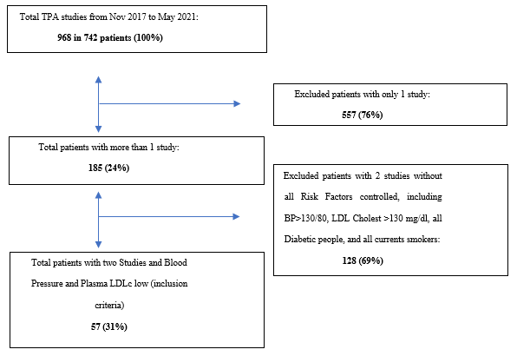

**Figure 1.** Block Diagram of the research.

The protocol was approved by the Committee on Independent Institutional Ethics of the National University of Córdoba and the Rusculleda Foundation. Reader reliability was estimated by randomly assigning scans of 22 patients to interpretation by 2 different readers.

**Inclusion and Exclusion criteria:** For this analysis, we include participants over 40 years of age, with a risk of acute myocardial infarction greater than 20% at ten years based on TPA, participants (with or without antihypertensive medication or Hypertension) with blood pressure < 130 mmHg systolic and < 80 mmHg diastolic based on blood pressure determination in clinical follow-up, ambulatory blood pressure monitoring or home blood pressure monitoring, LDL-C <100 mg/dl in at least two separate measurements >3 months apart, and written informed consent given. Excluded were current smokers, participants who had Type I or type II diabetes, a history of previous cardiovascular events, a history of neoplasm, kidney disease (eGFR less than 60 ml/min), endocrinological disease, rheumatological disease, immunological disease, those medicated with immunosuppressants, and those with a history of drug and/or alcohol abuse.

**10**

**TPA determination:** Measurement of TPA was performed with a high-resolution ultrasound machine (Ultrasound system Mindray M5, Shenzhen, P. R. China) and a linear probe between 5 to 10 MHz. It was performed by a single operator, informed of the participant’s sex, but blind to the participant’s history of vascular disease and risk factors (blood pressure, serum lipid levels, glycemia, and HbA1c). TPA was measured as previously described19. “Plaque was defined as a local thickening of the intima >1 mm in thickness. Measurements were made in magnified longitudinal views of each plaque seen in the right and left common, internal, and external carotid arteries. The plane in which the measurement of each plaque was made was chosen by panning around the artery until the view showing the largest extent of that plaque was obtained. The image was then frozen and magnified, and the plaque was measured by tracing around the perimeter with a cursor on the screen. The microprocessor in the scanner then displayed the cross-sectional area of the plaque. The operator then moved on to the next plaque and repeated the process until all visible plaques were measured. The sum of the cross-sectional areas of all plaques seen between the clavicle and the angle of the jaw was taken as total plaque area18.

**Hypertensive patients:** Patients with a previous diagnosis of hypertension and/or taking antihypertensive medication.

**Hypercholesterolemic patients:** Patients with a previous diagnosis of hypercholesterolemia and/or medication to treat dyslipidemia.

**Blood pressure determination:** Blood pressure was taken as the mean of three measurements performed on the left arm in the sitting position after five minutes of rest (OMRON Hem 705 sphygmomanometer, Vermont Hills, IL, USA).

**Serum cholesterol and triglycerides determination:** Blood lipids were measured from whole blood samples using routine methods in a central laboratory after a 12-hour fast (LACE Laboratory, Córdoba, ARG).

**Follow-up:** Carotid TPA determinations were made at baseline and at least one year later, with three additional visits made during this interval for measuring vital signs and laboratory results. All patients were treated according to established clinical guidelines21,22,23,24,25, but focusing on TPA evolution criteria. Plaque area regression was defined as a decrease of ≥5 mm2 from baseline; progression was defined as an increase of ≥5 mm2 from baseline; and stability was defined as either an increase or decrease of < 5 mm2, based on a previous study18. We divided the patients into two groups: progression vs. non-progression if the plaque regressed or was stable.

Statistical Analysis

Descriptive analyses include absolute frequencies, percentages, the mean and standard deviation for quantitative variables that follow a normal distribution, and median and interquartile range for variables with a non-normal distribution. Paired or unpaired t-tests were used, as required by the type of analysis appropriate to the hypothesis to be analyzed. Multiple regression analysis was used to determine the factors associated with progression status. Reliability was estimated for the entire sample. The accepted level of statistical significance for rejecting null hypotheses was p<0.05.

# Results

In total 742 participants were followed in this period, of which 57 people met the criteria for this study (mean age 71 + 8 years, 70% female, all white Latin). The average Risk post-TPA at 10 years for Acute Myocardial Infarction was very high (39.3 +18 %), the blood pressure (120.4/68.6 mmHg) and LDL-C (81 mg/dL) were at target levels during the year of study (Table 1 and 2).

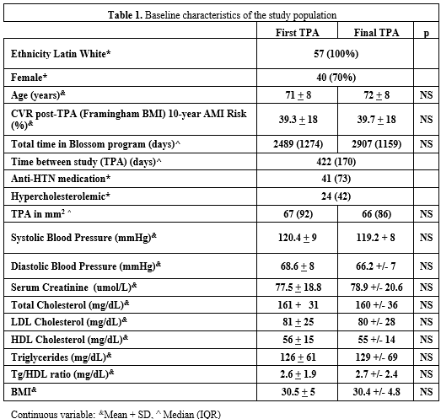

**11**

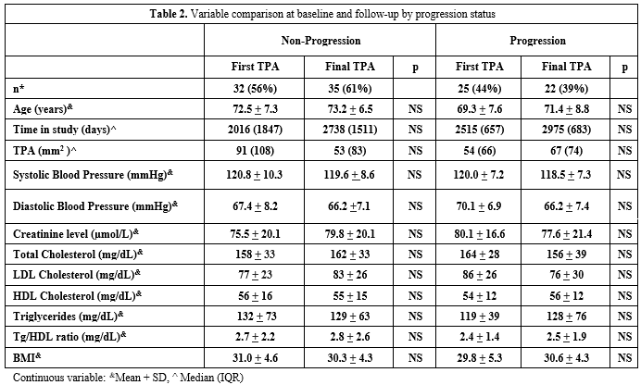

We found that 22 of 57 participants (38.6%) had plaque progression (Table 3).

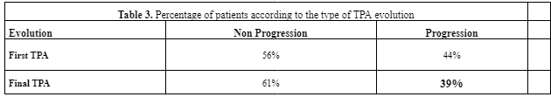

A Multiple regression analysis was performed with the evolution of TPA as the response variable and age, sex, systolic blood pressure, LDL-C, total cholesterol,Triglyceride/HDL-C ratio, creatinine, and time between studies as dependent variables, and we did not find any significant difference in variables, comparing progression vs. non-progression (Table 4). To determine if the status of Hypertension or Hypercholesteremia were relevant to these findings, a logistic regression model was carried out, using the evolution (progression/non-progression) at the study as the dependent variable, and age, sex, systolic blood pressure, serum LDLc, triglycerides-HDL ratio, creatinine, time between studies, presence of hypertension, presence of hypercholesterolemia of the second study as independent variable and did not find an association with the occurrence of progression (Table 4).

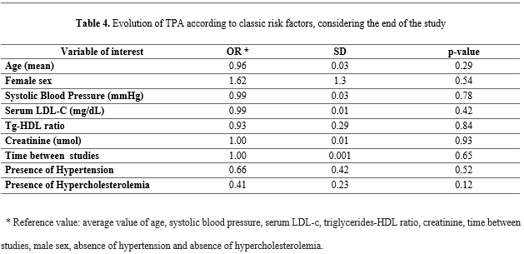

# Discussion

Current treatment of patients at high CV risk continues to be based on control of risk factors, even though there are known limitations to that approach. Current diagnostic techniques, such as the measurement of TPA, improves risk stratification, as demonstrated by our working group in Argentina26, Fuster et al. in the United States27, and Romanens in Switzerland. Regardless of the initial risk level (low, intermediate, high, very high), the suggested therapeutic goals in the management of these patients remain static, irrespective of the effect of the treatment on the progression of atherosclerosis. A meta-analysis reported a reduction in CV events with LDL cholesterol values much lower than the 70 mg/dl suggested presently29. A study in > 4,000 patients reported that renal failure and advanced age were related to “resistant atherosclerosis,” a situation identified in patients who, despite having very low levels of LDL-C, continue to have progression in their load of atherosclerosis burden30. Plasma levels of toxic metabolites produced by the intestinal microbiome were associated with increased TPA not explained by traditional risk factors (“unexplained atherosclerosis”)31. In our study, an association of age or creatinine level with progression as independent factors was not reproduced, probably because of the small number of patients, and the restricted range of these variables32. The ratio of Tg/HDL-C, recently shown to identify metabolic syndrome and insulin resistance, and an association with high TPA33, was not predictive of progression in our population, perhaps for the same reasons. Because factors other than traditional risk factors account for approximately half of plaque burden in linear regression modeling, treating only traditional risk factors to consensus target levels fails approximately half of patients: they have plaque progression, with twice the risk of those with non-progression. Measuring the burden of atherosclerosis not only permits more precise risk stratification, but also determines the effectiveness of treatment, and identifies patients at higher risk who need more intensive therapy based on “treating arteries” to be sure that the treatment instituted is effective.

# Limitations

The selection of our subjects was not based on a random population sample. Our population was derived from a follow-up cohort previously described, and the great majority was older than 60 years old, which limits the extrapolation of results to the general population. Even when our study has few participants, all these had blood pressure and serum LDL Cholesterol at target levels, which in real life follow up is very difficult.

# Conclusions

Our data evaluating a population with high CVD risk, which is representative of patients in real-life medical practice, show that controlling blood pressure and LDL-C target levels does not prevent the progression of atherosclerotic plaque in a substantial proportion of patients. Therapy based on measurement of plaque burden may be more effective than simply treating risk factors to target levels.

**12**

# Bibliografía

1. WHO. Global atlas on cardiovascular disease prevention and control. Geneva, 2011.
2. WHO. Global status report on non-communicable diseases 2014. Geneva, 2014.
3. WHO. The World Health Report 2002: reducing risks, promoting healthy life. Geneva, 2002.
4. Nichols M, Townsend N, Luengo-Fernandez R, et al. European Cardiovascular Disease Statistics 2012. European Heart Network, Brussels and European Society of Cardiology. Sophia Antipolis. 162.
5. Pattersson PP, Yang Cao, Torbjorn B, et al. Body fat percentage and CRP correlates with a composite score of vascular risk markers in healthy, young adults - The Lifestyle, Biomarkers, and Atherosclerosis (LBA) study. BMC Cardiovasc Disord. 2020; 20(1): 77.
6. d'Agostino RB Sr, Grundy S, Sullivan LM, Wilson P; CHD Risk Prediction Group. Validation of the Framingham coronary heart disease prediction scores: results of a multiple ethnic groups investigation. JAMA. 2001; 286: 180-187.
7. European Guidelines on CVD Prevention in Clinical Practice 2016. Eur J Prev Cardiol. 2016; 23(11): NP1-NP96.
8. Assmann G, Schulte H, Cullen P, Seedorf U. Assessing risk of myocardial infarction and stroke: new data from the Prospective Cardiovascular Munster (PROCAM) study. Eur J Clin Invest. 2007;37(12):925-32.
9. Adams A, Bojara W, Romanens M. The Determination of the Plaque Burden on the Carotid Artery with Ultrasound Significantly Improves the Risk Prediction in Middle-Aged Subjects Compared to PROCAM: An Outcome Study. Cardiol Res. 2020;11(4):233-8.
10. Cooney MT, Dudina AL and Graham IM. Value and Limitations of Existing Scores for the Assessment of Cardiovascular Risk. A Review for Clinicians. J Am Coll Cardiol. 2009; 54: 1209-1227.
11. Gaede P, Lund-Andersen H, Parving H-H, et al. Effects on multifactorial intervention on mortality in Type 2 Diabetes. N Engl J Med. 2008; 358:580-591.
12. Lopez AD et al. Global and regional burden of disease and risk factors, 2001: systematic analysis of population health data. Lancet. 2006; 367(9524): 1747–57.
13. Manuel DG et al. Revisiting Rose: strategies for reducing coronary heart disease. BMJ. 2006; 332: 659–662.
14. WHO. Prevention of recurrent heart attacks and strokes in low- and middle-income populations.Evidence-based recommendations for policy makers and health professionals. Geneva, 2003.
15. Spence JD, Hackam DG. Treating Arteries Instead of Risk Factors A Paradigm Change in Management of Atherosclerosis. Stroke. 2010; 41: 1193-1199.
16. Baber U, Mehran R, Sartori S, Schoos MM, Sillesen H, Muntendam P et al. Prevalence, impact, and predictive value of detecting subclinical coronary and carotid atherosclerosis in asymptomatic adults: the BioImage study. J Am Coll Cardiol. 2015;65(11):1065-74.
17. Spence JD. Time course of atherosclerosis regression. Atherosclerosis. 2014;235(2):347-8.
18. Spence JD, Eliasziw M, DiCicco M, Hackam DG, Galil R and Lohmann T. Carotid plaque area: a tool for targeting and evaluating vascular preventive therapy. Stroke. 2002; 33:2916-22.
19. Perez HA, Adeoye AO, Aballay L et al. An Intensive follow up in subject with cardiometabolic high risk. Nutr Metab Cardiovas. 2021; 31: 2860-2869.
20. D’Agostino RB, Vasan RS, Pencina MJ et al. General Cardiovascular risk profile for use in primary care. The Framingham Heart Study. Circulation. 2008; 117: 743-753.

**13**

1. Arterial Hypertension Guide. SAHA. [WEB] http://www.saha.org.ar/pdf/GUIA_SAHA_VERSION_COMPLETA.pdf
2. Diabetes Guide. Argentine Diabetes Society. [WEB]http://www.diabetes.org.ar/docs/2010_10_SAD_Guia_del_Tratamiento_de_la_D M2.pdf
3. NCEP III: Executive summary of the third report of the National Cholesterol Education Program Expert Panel on Detection, Evaluation, and Treatment of High Blood Cholesterol in Adults (Adult Treatment Pane III). JAMA. 2001; 285: 2486-2497.
4. National Guide to the Treatment of Tobacco Addiction. [WEB]http://www.femeba.org.ar/documentos/download/436-tratamiento_adiccion_tabaco.pdf
5. WHO Guides 2010 for Physical Activity. [WEB]http://whqlibdoc.who.int/publications/2010/9789243599977 spa.pdf.
6. Perez HA, Garcia NH, Spence JD, et al. Adding carotid total plaque area to the Framingham risk score improves cardiovascular risk classification. Archiv of Med Sci.2016; 12(3): 512-520.
7. Usman B, Mehran S, Sartori M, et al. Detection and impact of subclinical coronary and carotid atherosclerosis on cardiovascular risk prediction and reclassification in asyntomatic us adults: insights from the high-risk plaque bioimage study. J Am Coll Cardiol. 2014; 63: A998.
8. Romanens M, Sudano I, Adams A, et al. Advanced carotid atherosclerosis in middle-aged subjects: comparison with PROCAM and SCORE risk categories, the potential for reclassification and costefficiency of carotid ultrasound in the setting of primary care. Swiss Med Wkly. 2019; 149: w20006.
9. Sabatine MS, Wivviott SD, KyungAh Im, et al. Efficacy and Safety of Further Lowering of Low-Density Lipoprotein Cholesterol in Patients Starting with Very Low Levels A Meta-analysis. JAMA Cardiology. 2018; 3(9): 823-828.
10. Spence DJ and Solo K. Resistant Atherosclerosis. The need to monitor of plaque burden. Stroke. 2017; 48(6): 1624-1629.
11. Bogiatzi C, Gloor G, Allen-Vercoe E et al. Metabolic products of the intestinal microbiome and extremes of atherosclerosis. Atherosclerosis. 2018, 273: 91-97.
12. Bland JM, Altman DG. Correlation in restricted ranges of data. BMJ. 2011; 342: 577.
13. Azarpazhooh MR, Najafi F, Darbandi, et al. Triglyceride/High-Density Lipoprotein Cholesterol Ratio: A Clue to Metabolic Syndrome, Insulin Resistance, and Severe Atherosclerosis. Lipids. 2021; 56: 405-412.



**14**

**xx**